Lali Guras Nepali American Women, Chicago

To,
Dr Mahabir Pun, National Innovation Centre Nepal
It is our honor to present a collective effort of donations to help COVID victims in Nepal on behalf of the Lali Guras, Nepali American Women, Chicago. The following list is the names of the members who were able to contribute.
- Kabita Joshi
- Sangita Bogati
- Pramila Adhikari
- Anjali Shrestha
- Jyoti Adhikary
- Rewa Khadka
- Pooja Chapagain
- Leena Shretha
- Rakshya Ghimire
- Shreejana Paudel
- Mala Jha
- Bulu Jamkatel
- Rummy Pant
- Komal Dutta
- Smarika Paudel Sitaula
- Pooja Kunwar
- Anita Baral
- Kshitiz Shrestha
- Archana Regmi
- Smriti Thapa
- Usha Pudasaini
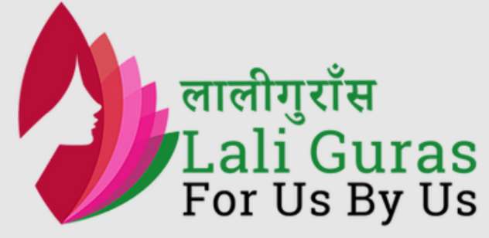
- Richa Rayamajhi
- Anima Regmi
- Reshika Dhakal
Total donations collected: $1,084
Thank you,
Jyoti Adhikary
President, Lali Guras Nepali American Women, Chicago

