Laliguras Nepali School

Laliguras Nepali School is school for our Nepali kids in Chicagoland area, Illinois. The main aim of this school is to help kids learn and understand Nepali, so that they can have two-way communication with each other and their family members back in Nepal. An inauguration ceremony was held on March 12th, 2023, at Niles Library to start the first day of the school. Inauguration was done by President of Laliguras Mrs. Jyoti Adhikari and honorable retired schoolteacher from Nepal, Mrs. Kamala Kunwar. Mrs. Adhikari said that we should teach our kids our culture and our language. Mrs. Kunwar talked about 3D’s to the kids, Devotion, Dedication, and Discipline and asked parents to help kids to learn our language. Both Nepali as well as American anthem were played during the inauguration.

Lot of volunteers attended on the event. Mr. Madan Baral, presented the syllabus for spring session which will run every Sunday till June 11th. All the events are going to be via Zoom from 5PM to 6PM, except on third Sundays of every month, which will be on site across different libraries and places in Chicagoland Area. Mr. Binod Dhungel read a story to kids in Nepali and translated them to English so that kids can understand. All the kids patiently listened to the story and were able to tell the moral of the story from each desk. The first program was very well attended by the kids, and to create more interaction, Host Mrs. Smarika Paudel Sitaula populated some questions to the kids for some nice prizes.

During the final session of the program, all the kids wrote their names in Nepali. They were asked to put different colors in their name as an art. Everybody loved the art and were able to finish the art in quick time. Once they completed the art, they were able to get some snacks and goody bags from volunteers. Kids really enjoyed the program. One of the kids reiterated “We should have this kind of event more frequently, so that we can learn as well as we can meet our friends”.

Laliguras Nepali School is run by Volunteers for the kids. Lot of hard work has been put by lot of volunteers to create a schedule as well as syllabus. Mr. Baral also put some thoughts on it and uploaded a snapshot for the plan on the website http://nepalischools.com. The goal of this spring session for all the kids is to have two sentences read and write by each of them. The classes will follow the school holiday calendar and won’t have any sessions during long weekend or spring break. Laliguras Nepali School always supports the volunteers and welcomes anyone who wants to help during the event. Spring session on site sessions are going to be held at following locations.
- Niles Library, Mar 12th, 2023
- Schaumburg Library, April 16th, 2023
- Naperville Library, May 21st, 2023 (Location TBD)

Laliguras Nepali school will continue after summer break. There is a plan to start in the fall session starting from 3rd week of August. Any interested parents can contact Laliguras Nepali School Volunteers to enroll for the fall session. Language is part of culture, and to able to teach kids our culture and language is really a proud moment.
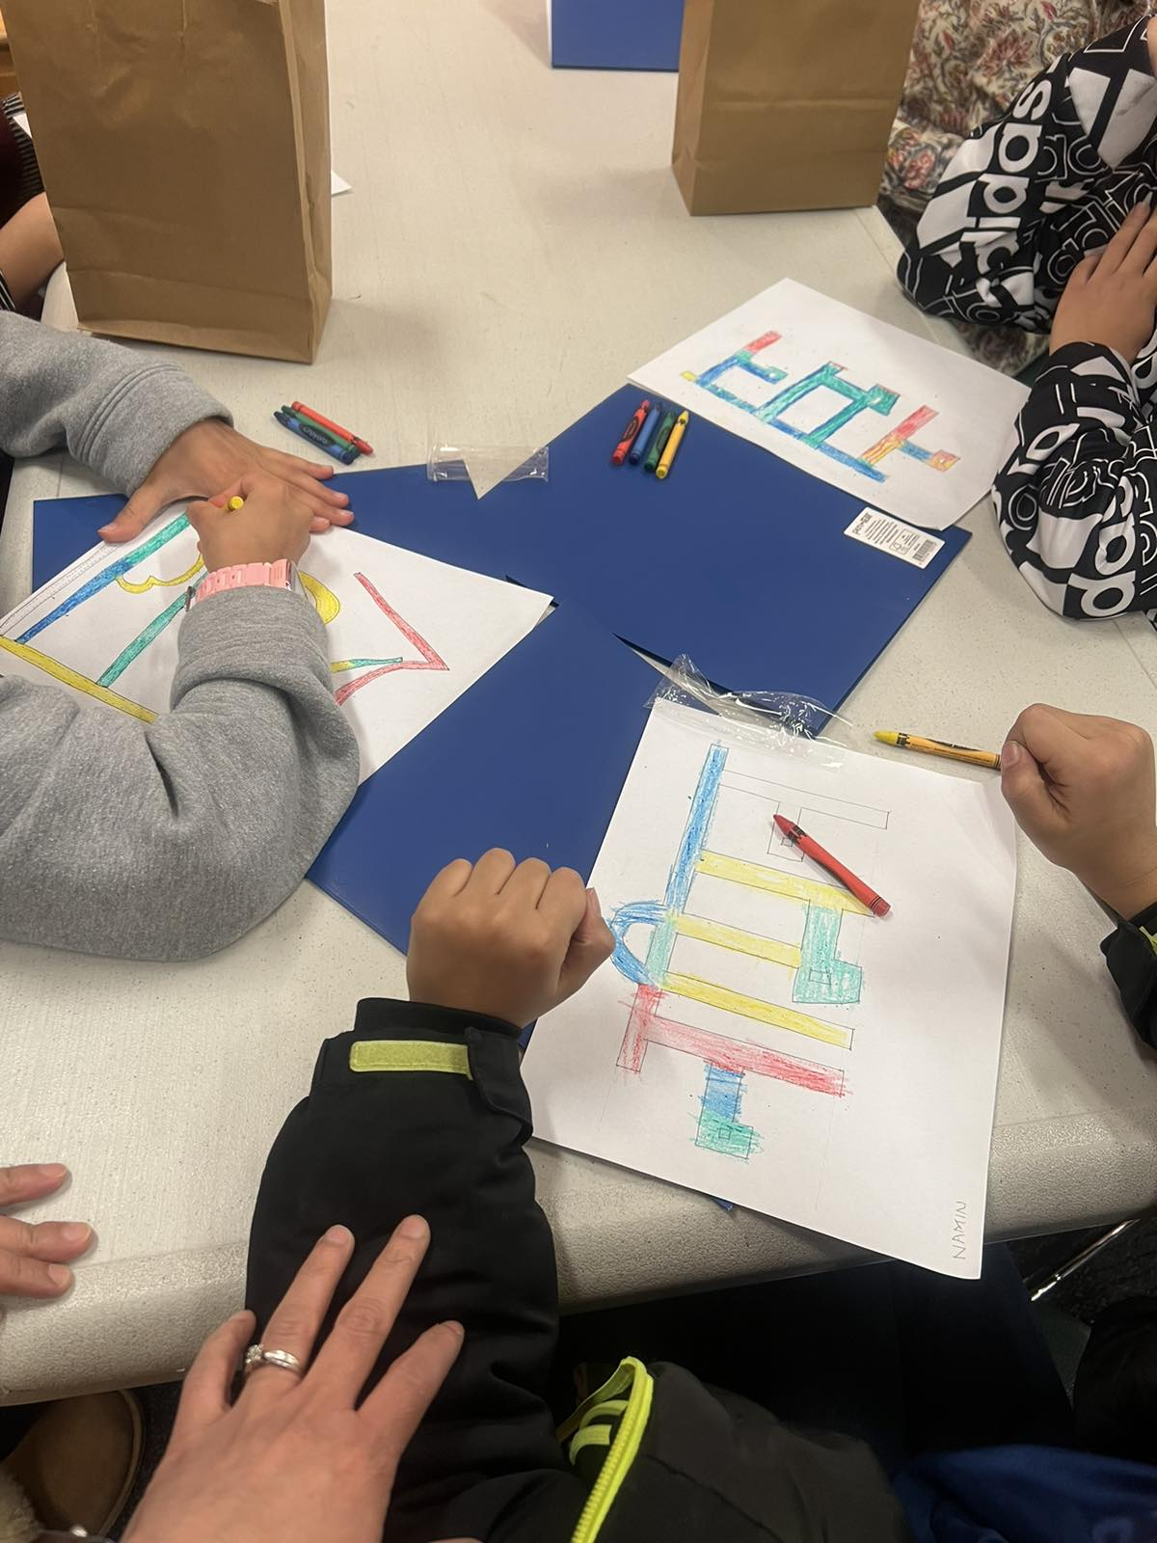

  - By Meena Pant

